**Question No. 1**

[PSEUDOCODE](https://www.google.com/search?rlz=1C1ONGR_enIN1012IN1012&q=what+is+pseudocode&spell=1&sa=X&ved=2ahUKEwi4_6eW2av5AhWf-DgGHQuOD04QBSgAegQIARAz)

/*

Lab Assignment

/1/

WAP to find out the smallest and largest element stored in an array of n

integers.

*/

#include<stdio.h>

int main()

{

int a[50],i,n,large,small;

printf("Number of elements:");

scanf("%d",&n);

printf("Enter the Array:");

for(i=0;i<n;++i)

scanf("%d",&a[i]);

large=small=a[0];

for(i=1;i<n;++i)

{

if(a[i]>large)

large=a[i];

if(a[i]<small)

small=a[i];

}

printf("The largest element is %d",large);

printf("\nThe smallest element is %d",small);

return 0;

}

OUTPUT 1

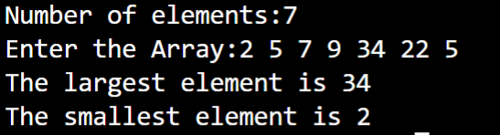

**Question No. 2**

[PSEUDOCODE](https://www.google.com/search?rlz=1C1ONGR_enIN1012IN1012&q=what+is+pseudocode&spell=1&sa=X&ved=2ahUKEwi4_6eW2av5AhWf-DgGHQuOD04QBSgAegQIARAz)

/*

Lab Assignment

/2/

WAP to reverse the contents of a dynamic array of n elements.

*/

#include<stdio.h>

#include<stdlib.h>

int main()

{

      int *p,n,i;

      printf("How many numbers you want to enter: ");

      scanf("%d",&n);

      p=(int*)malloc(n * sizeof(int));

      printf("\nEnter %d Numbers:\n\n",n);

      for(i=0;i<n;i++)

      {

            scanf("%d",p+i);

      }

      printf("\nArray in Reverse Order: \n\n");

      for(i=n-1;i>=0;i--)

      {

            printf(" %d",*(p+i));

      }

      return 0;

}

OUTPUT 2

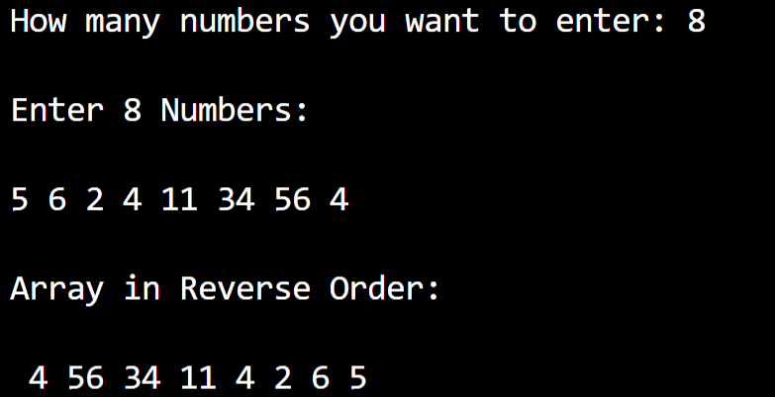

**Question No. 3**

[PSEUDOCODE](https://www.google.com/search?rlz=1C1ONGR_enIN1012IN1012&q=what+is+pseudocode&spell=1&sa=X&ved=2ahUKEwi4_6eW2av5AhWf-DgGHQuOD04QBSgAegQIARAz)

/*

Lab Assignment

/3/

WAP to search an element in a dynamic array of n numbers.

*/

#include <stdio.h>

#define MAX_SIZE 100  // Maximum array size

int main()

{

    int arr[MAX_SIZE];

    int size, i, toSearch, found;

    printf("Enter size of array: ");

    scanf("%d", &size);

    printf("Enter elements in array: ");

    for(i=0; i<size; i++)

    {

        scanf("%d", &arr[i]);

    }

    printf("\nEnter element to search: ");

    scanf("%d", &toSearch);

    found = 0;

    for(i=0; i<size; i++)

    {

        if(arr[i] == toSearch)

        {

            found = 1;

            break;

        }

    }

    if(found == 1)

    {

        printf("\n%d is found at position %d", toSearch, i + 1);

    }

    else

    {

        printf("\n%d is not found in the array", toSearch);

    }

    return 0;

}

OUTPUT 3

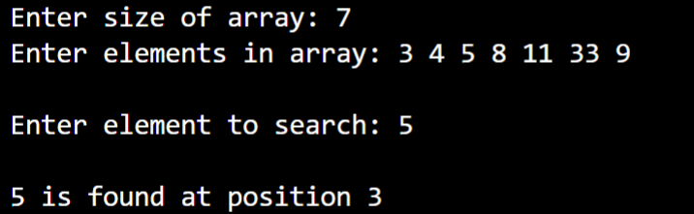

**Question No. 4**

[PSEUDOCODE](https://www.google.com/search?rlz=1C1ONGR_enIN1012IN1012&q=what+is+pseudocode&spell=1&sa=X&ved=2ahUKEwi4_6eW2av5AhWf-DgGHQuOD04QBSgAegQIARAz)

/*

Lab Assignment

/Q4/

WAP to sort a dynamic array of n numbers.

 */

#include<stdio.h>

#include<stdlib.h>

int main()

{

      int *a,n,i,j,t;

      printf("How many numbers you want to be sorted: ");

      scanf("%d",&n);

      a=(int *)malloc(n *sizeof(int));

      printf("\nEnter %d Numbers: \n\n",n);

      for(i=0;i<=n-1;i++)

      {

            scanf("%d", (a+i));

      }

      for(i=0;i<n;i++)

      {

            for(j=0;j<=i;j++)

            {

                  if(*(a+i)<*(a+j))

                  {

                        t=*(a+i);

                        *(a+i)=*(a+j);

                        *(a+j)=t;

                  }

            }

      }

      printf("\nSorting in Ascending Order: \n");

      for(i=0;i<n;i++)

      printf("\n%d",*(a+i));

      return 0;

}

OUTPUT 4

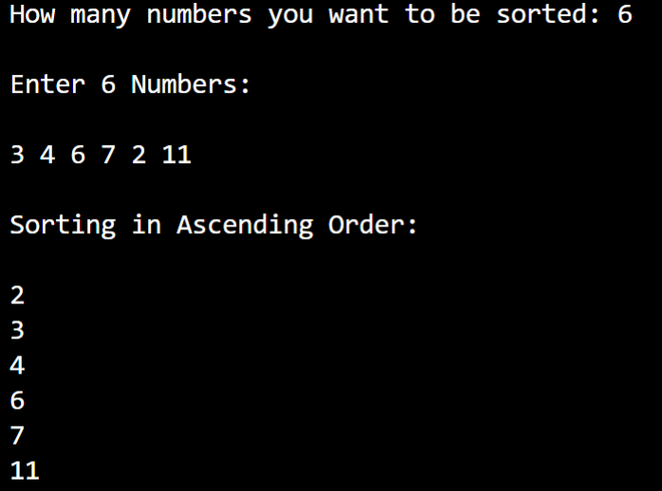

**Question No. 5**

[PSEUDOCODE](https://www.google.com/search?rlz=1C1ONGR_enIN1012IN1012&q=what+is+pseudocode&spell=1&sa=X&ved=2ahUKEwi4_6eW2av5AhWf-DgGHQuOD04QBSgAegQIARAz)

/*

Lab Assignment

/Q5/

Given an unsorted dynamic array of size n, WAP to find and display the number of elements between two elements a and b (both inclusive). E.g. Input : arr = [1, 2, 2, 7, 5, 4], a=2 and b=5, Output : 4 and the number are: 2, 2, 5, 4.

*/

#include <stdio.h>

int main()

{

    int n,i,a,b,c=0,d=2;

    printf("Enter size of array: ");

    scanf("%d",&n);

    printf("Enter elements of array: ");

    int arr[n];

    for(i=0;i<n;i++){

        scanf("%d",&arr[i]);

    }

    printf("\nEnter lower limit element & upper limit element respectively: ");

    scanf("%d %d",&a,&b);

    for(i=0;i<n;i++){

        if(arr[i]==a || arr[i]==b){

            c++;

            d=0;

        }

        if(arr[i]>a && arr[i]<b){

            c++;

        }

    }

    printf("Number of elements in between two elements (Both Inclusive) = %d",c+d);

    return 0;

}

OUTPUT 5

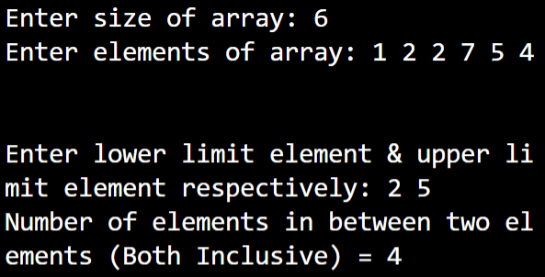

**Question No. 6**

[PSEUDOCODE](https://www.google.com/search?rlz=1C1ONGR_enIN1012IN1012&q=what+is+pseudocode&spell=1&sa=X&ved=2ahUKEwi4_6eW2av5AhWf-DgGHQuOD04QBSgAegQIARAz)

/*

Lab Assignment

/Q6/

Given a dynamic array, WAP to print the next greater element (NGE) for every element. The next greater element for an element x is the first greater element on the right side of x in array. Elements for which no greater element exist, consider next greater element as -1. E.g. For the input array [2, 5, 3, 9, 7], the next greater elements for each elements are as follows.

Element NGE

2       5

5       9

3       9

9       -1

7 -     1

*/

#include<stdio.h>

void printNGE(int arr[], int n)

{

    int next, i, j;

    for (i=0; i<n; i++)

    {

        next = -1;

        for (j = i+1; j<n; j++)

        {

            if (arr[i] < arr[j])

            {

                next = arr[j];

                break;

            }

        }

        printf("\t%d\t|\t %d\n", arr[i], next);

    }

}

int main()

{

    int arr[]= {2,5,3,9,7};

    int n = sizeof(arr)/sizeof(arr[0]);

    printf("\n\n\tElement\t|\tNGE\n");

    printf("\t------------------\n");

    printNGE(arr, n);

    printf("\n");

    return 0;

}

OUTPUT 6

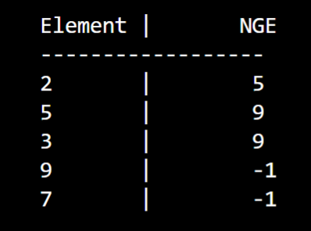

**Question No.7**

[PSEUDOCODE](https://www.google.com/search?rlz=1C1ONGR_enIN1012IN1012&q=what+is+pseudocode&spell=1&sa=X&ved=2ahUKEwi4_6eW2av5AhWf-DgGHQuOD04QBSgAegQIARAz)

/*

Lab Assignment

/Q7/ Let A be nXn square dynamic matrix. WAP by using appropriate user defined functions for the following:

a) Find the number of nonzero elements in A

b) Find the sum of the elements above the leading diagonal.

c) Display the elements below the minor diagonal.

d) Find the product of the diagonal elements.*/

#include <stdio.h>

#include <stdlib.h>

void non(int **arr, int n)

{

    int non = 0;

    for (int i = 0; i < n; i++)

    {

        for (int j = 0; j < n; j++)

        {

            if (arr[i][j] != 0)

            {

                non++;

            }

        }

    }

    printf("\nThe number of nonzero elements is %d\n", non);

}

void sum(int **arr, int n)

{

    int sum = 0;

    for (int i = 0; i < n; i++)

    {

        for (int j = i + 1; j < n; j++)

        {

            sum = sum + arr[i][j];

        }

    }

    printf("\nThe sum of the elements above the leading diagonal is %d\n",sum);

}

void minor(int **arr, int n)

{

    int sum = 0;

    int f = n-2;

    printf("\nThe elements below the minor diagonal are \n");

    for (int i = 1; i <n;i++)

    {

        for (int j = n-1; j >f;j--)

        {

            printf("%d ",arr[i][j]);

        }

        f--;

    }

}

void product(int **arr, int n)

{

    int k = 1;

    for (int i = 0; i < n;i++)

    {

        for (int j = i; j == i;j++)

        {

            k = k * arr[i][j];

        }

    }

    printf("\n\nThe product of the diagonal elements is %d\n", k);

}

int main()

{

    int n, i, j;

    int **arr;

    printf("\nEnter the size of the  square matrix A[ n x n ]\n");

    scanf("%d", &n);

    arr = (int **)malloc(n * sizeof(int *));

    for (i = 0; i < n; i++)

    {

        arr[i] = (int *)malloc(n * sizeof(int));

    }

    int g = 1;

    for (i = 0; i < n; i++)

    {

    printf("Enter %d Element in Row %d\n", n,(g++));

    for (j = 0; j < n; j++)

    {

        scanf("%d", &arr[i][j]);

        }

    }

    printf("\n");

    printf("The Matrix is\n");

    for (i = 0; i < n; i++)

    {

        for (j = 0; j < n; j++)

        {

            printf("%d ", arr[i][j]);

        }

        printf("\n");

    }

    printf("\n");

    non(arr, n);

    sum(arr, n);

    minor(arr, n);

    product(arr, n);

    return 0;

}

OUTPUT 7

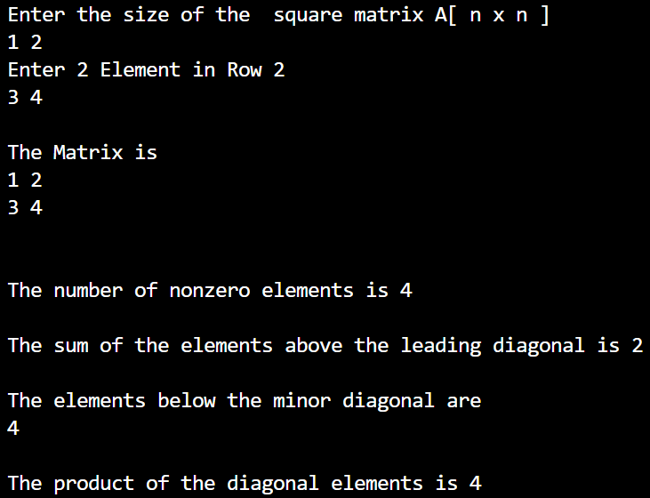

HOME ASSIGNMENT

**Question No.1**

[PSEUDOCODE](https://www.google.com/search?rlz=1C1ONGR_enIN1012IN1012&q=what+is+pseudocode&spell=1&sa=X&ved=2ahUKEwi4_6eW2av5AhWf-DgGHQuOD04QBSgAegQIARAz)

/*

Home Assignment

/1/

Given an unsorted dynamic array arr and two numbers x and y, find the minimum distance between x and y in arr. The array might also contain duplicates. You may assume that both x and y are different and present in arr. Input: arr[] = {3, 5, 4, 2, 6, 5, 6, 6, 5, 4, 8, 3}, x = 3, y = 6

*/

#include <stdio.h>

#include <stdlib.h>

#include <limits.h>

int minDist(int arr[], int n, int x, int y)

{

   int i, j;

   int min_dist = INT_MAX;

   for (i = 0; i < n; i++)

   {

     for (j = i+1; j < n; j++)

     {

         if( (x == arr[i] && y == arr[j] ||

              y == arr[i] && x == arr[j]) && min_dist > abs(i-j))

         {

              min_dist = abs(i-j);

         }

     }

   }

   return min_dist;

}

int main()

{

    int arr[] = {3, 5, 4, 2, 6, 5, 6, 6, 5, 4, 8, 3};

    int n = sizeof(arr)/sizeof(arr[0]);

    int x = 3;

    int y = 6;

    printf("Minimum distance between %d and %d is %d", x, y,minDist(arr, n, x, y));

    return 0;

}

OUTPUT 1



**Question No.2**

[PSEUDOCODE](https://www.google.com/search?rlz=1C1ONGR_enIN1012IN1012&q=what+is+pseudocode&spell=1&sa=X&ved=2ahUKEwi4_6eW2av5AhWf-DgGHQuOD04QBSgAegQIARAz)

/*

Home Assignment

/2/

WAP to find out the second smallest and second largest element stored in

a dynamic array.

*/

#include <stdio.h>

int main()

{

    int n;

    printf("Enter the number of elements:");

    scanf("%d",&n);

    printf("Enter the array elements :");

    int a[n];

    for(int i=0;i<n;i++)

    {

        scanf("%d",&a[i]);

    }

    for(int i=0;i<n;i++)

    {

        int temp;

        for(int j=i+1; j<n ;j++)

        {

            if(a[i]<a[j])

            {

                temp=a[i];

                a[i]=a[j];

                a[j]=temp;

            }

        }

    }

    printf("The Second Smallest element is %d",a[n-2]);

    printf("\n");

    printf("The Second Largest element is %d",a[1]);

    return 0;

}

OUTPUT 2

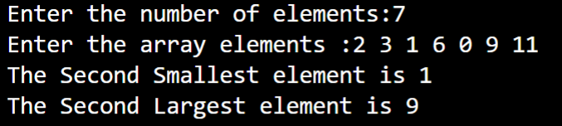

**Question No.3**

[PSEUDOCODE](https://www.google.com/search?rlz=1C1ONGR_enIN1012IN1012&q=what+is+pseudocode&spell=1&sa=X&ved=2ahUKEwi4_6eW2av5AhWf-DgGHQuOD04QBSgAegQIARAz)

/*

Home Assignment

/3/

WAP to arrange the elements of a dynamic array such that all even numbers are followed by all odd numbers.

*/

#include <stdio.h>

 int main()

{

    int a[10000],b[10000],i,n,j,k,temp,c=0;

    printf("Enter size of the  array : ");

    scanf("%d", &n);

    printf("Enter elements in array : \n");

    for(i=0; i<n; i++)

    {

        scanf("%d",&a[i]);

        if(a[i]%2==1)

         c++;

    }

    for(i=0; i<n-1; i++)

    {

        for(j=0; j<n-i-1; j++)

        {

           if(a[j]>a[j+1])

           {

            temp=a[j];

            a[j]=a[j+1];

            a[j+1]=temp;

           }

        }

    }

    k=0;

    j=n-c;

    for(i=0; i<n; i++)

    {

        if(a[i]%2==0)

        {

            if(k<n-c)

              b[k++]=a[i];

        }

        else

        {

            if(j<n)

              b[j++]=a[i];

        }

    }

    printf("\nThe elements of a dynamic array such that all\neven numbers are followed by all odd numbers are:\n\n");

    for(i=0; i<n; i++)

    {

        a[i]=b[i];

       printf("%d ",a[i]);

    }

    printf("\n");

}

OUTPUT 3

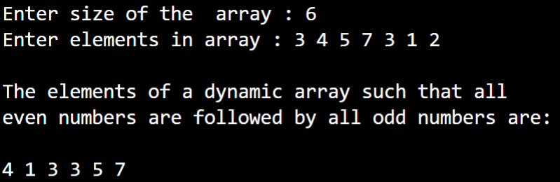

**Question No.4**

[PSEUDOCODE](https://www.google.com/search?rlz=1C1ONGR_enIN1012IN1012&q=what+is+pseudocode&spell=1&sa=X&ved=2ahUKEwi4_6eW2av5AhWf-DgGHQuOD04QBSgAegQIARAz)

/*

Home Assignment

/4/

Write a program to replace every element in the dynamic array with the

next greatest element present in the same array.

*/

#include<stdio.h>

#include<stdlib.h>

int main()

{

    int *a,n,i,j,max;

    printf("Enter size of array:");

    scanf("%d",&n);

    a=malloc(sizeof(int)*n);

    printf("Enter %d Elements:",n);

    for(i=0;i<n;i++)

    {

        scanf("%d",&a[i]);

    }

    for(i=0;i<n-1;i++)

    {

        max=a[i+1];

        for(j=i+2;j<n;j++)

        {

            if(a[j]>max)

            {

                max=a[j];

            }

        }

        a[i]=max;

    }

    printf("Output Result :\n");

    for(i=0;i<n;i++)

    {

        printf("%d ",a[i]);

    }

    return 0;

}

OUTPUT 4

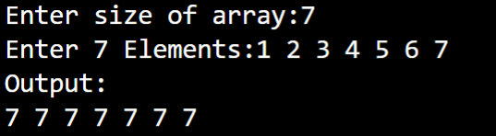

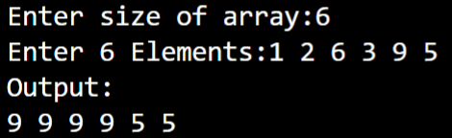

**Question No.5**

[PSEUDOCODE](https://www.google.com/search?rlz=1C1ONGR_enIN1012IN1012&q=what+is+pseudocode&spell=1&sa=X&ved=2ahUKEwi4_6eW2av5AhWf-DgGHQuOD04QBSgAegQIARAz)

/*

Home Assignment

/5/

WAP to replace every dynamic array element by multiplication of previous

and next of an n element.*/

#include<stdio.h>

void newArryPrevNext(int arr1[], int n)

{

    if (n <= 1)

      return;

    int pre_elem = arr1[0];

    arr1[0] = arr1[0] * arr1[1];

    for (int i=1; i<n-1; i++)

    {

        int cur_elem = arr1[i];

        arr1[i] = pre_elem * arr1[i+1];

        pre_elem = cur_elem;

    }

    arr1[n-1] = pre_elem * arr1[n-1];

}

int main()

{

    int arr1[] = {1,2, 3, 4, 5, 6};

    int n = sizeof(arr1)/sizeof(arr1[0]);

  int i = 0;

  printf("The given array is:  \n");

  for(i = 0; i < n; i++)

    {

      printf("%d  ", arr1[i]);

    }

    printf("\n");

  printf("The new array is: \n");

    newArryPrevNext(arr1, n);

    for (int i=0; i<n; i++)

      printf("%d ", arr1[i]);

    return 0;

}

OUTPUT 5  
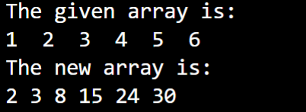

**Question No.6**

[PSEUDOCODE](https://www.google.com/search?rlz=1C1ONGR_enIN1012IN1012&q=what+is+pseudocode&spell=1&sa=X&ved=2ahUKEwi4_6eW2av5AhWf-DgGHQuOD04QBSgAegQIARAz)

/*

Home Assignment

/6/

WAP to sort rows of a dynamic matrix having m rows and n columns in

ascending and columns in descending order.

*/

#include <stdio.h>

void main()

{

    static int array1[10][10], array2[10][10];

    int i, j, k, a, m, n;

    printf("Enter the order of the matrix \n");

    scanf("%d %d", &m, &n);

    printf("Enter co-efficients of the matrix \n");

    for (i = 0; i < m; ++i)

    {

        for (j = 0; j < n; ++j)

        {

            scanf("%d", &array1[i][j]);

            array2[i][j] = array1[i][j];

        }

    }

    printf("The given matrix is \n");

    for (i = 0; i < m; ++i)

    {

        for (j = 0; j < n; ++j)

        {

                printf(" %d", array1[i][j]);

        }

        printf("\n");

    }

    printf("After arranging rows in ascending order\n");

    for (i = 0; i < m; ++i)

    {

        for (j = 0; j < n; ++j)

        {

            for (k =(j + 1); k < n; ++k)

            {

                if (array1[i][j] > array1[i][k])

                {

                    a = array1[i][j];

                    array1[i][j] = array1[i][k];

                    array1[i][k] = a;

                }

            }

        }

    }

    for (i = 0; i < m; ++i)

    {

        for (j = 0; j < n; ++j)

        {

            printf(" %d", array1[i][j]);

        }

        printf("\n");

    }

    printf("After arranging the columns in descending order \n");

    for (j = 0; j < n; ++j)

    {

        for (i = 0; i < m; ++i)

        {

            for (k = i + 1; k < m; ++k)

            {

                if (array2[i][j] < array2[k][j])

                {

                    a = array2[i][j];

                    array2[i][j] = array2[k][j];

                    array2[k][j] = a;

                }

            }

        }

    }

    for (i = 0; i < m; ++i)

    {

        for (j = 0; j < n; ++j)

        {

            printf(" %d", array2[i][j]);

        }

        printf("\n");

    }

}

OUTPUT 6

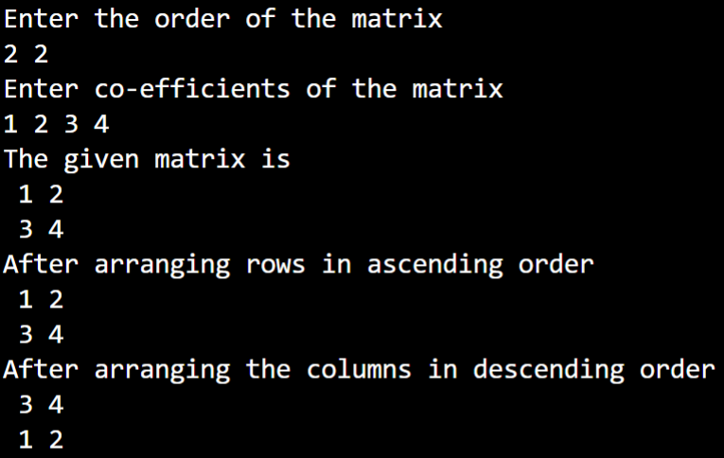

**Question No.7**

[PSEUDOCODE](https://www.google.com/search?rlz=1C1ONGR_enIN1012IN1012&q=what+is+pseudocode&spell=1&sa=X&ved=2ahUKEwi4_6eW2av5AhWf-DgGHQuOD04QBSgAegQIARAz)

/*

Home Assignment

/7/

WAP to find out the kth smallest and kth largest element stored in a dynamic array of n integers, where k<n.

*/

#include<stdio.h>

void find(int a[20],int n,int k,int l)

{

    int i,j,t;

    for(i=0;i<n;i++)

    {

        for(j=0;j<n-i-1;j++)

        {

            if(a[j]>a[j+1])

            {

                t=a[j];

                a[j]=a[j+1];

                a[j+1]=t;

            }

        }

    }

    printf("The sorted list is: ");

    for(i=0;i<n;i++)

        printf("%d ",a[i]);

    if(l==1)

    {

        for(i=n-1;i>=n-k;i--);

        printf("\nThe %dth largest element is: %d",k,a[i+1]);

    }

    else

    {

        for(i=0;i<k;i++);

        printf("\nThe %dth smallest element is: %d",k,a[i-1]);

    }

}

int main()

{

    int i,n,a[20],k,l;

    printf("Enter the number of elements: ");

    scanf("%d",&n);

    printf("Enter the array elements: ");

    for(i=0;i<n;i++)

        scanf("%d",&a[i]);

    printf("Enter the value of k: ");

    scanf("%d",&k);

    printf("Enter 1 for kth largest or 0 for kth smallest: ");

    scanf("%d",&l);

    find(a,n,k,l);

}

OUTPUT 7

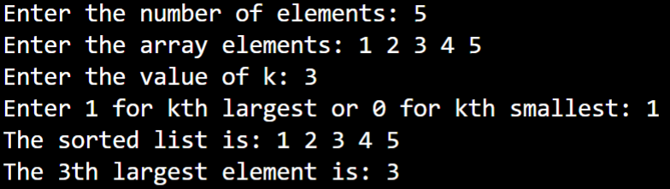

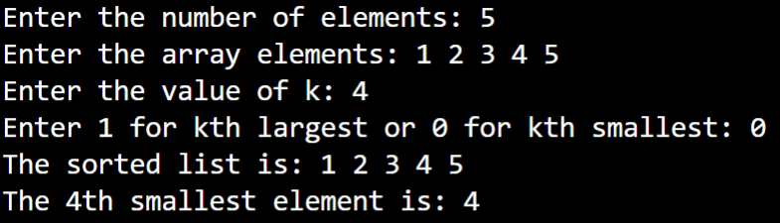

**Question No.8**

[PSEUDOCODE](https://www.google.com/search?rlz=1C1ONGR_enIN1012IN1012&q=what+is+pseudocode&spell=1&sa=X&ved=2ahUKEwi4_6eW2av5AhWf-DgGHQuOD04QBSgAegQIARAz)

/*

Home Assignment

/8/

WAP to find the largest number and counts the occurrence of the largest

number in a dynamic array of n integers using a single loop.

*/

#include <stdio.h>

#include <stdlib.h>

#include <string.h>

#include <math.h>

#include <ctype.h>

int main()

{

int arrayNum[15];

int a;

int max=0;

int location;

for( a=0; a < 15; a++)

    {

        printf("Enter element %d:", a);

        scanf("%d",&arrayNum[a]);

    }

for(a=0; a < 15; a++)

    {

        printf("%d\n", arrayNum[a]);

    }

for (a = 1; a < 15; a++)

  {

    if (arrayNum[a] > max)

    {

       max  = arrayNum[a];

       location = a+1;

    }

    }

printf("Max element in the array in the location %d and its value %d\n", location, max);

int NoOfOccurances;

NoOfOccurances = 0;

for(a=0; a<15; a++)

    {

        if(max == arrayNum[a])

        {

             NoOfOccurances++;

        }

    }

 printf("Number %d: %d occurences\n", max,NoOfOccurances);

return 0;

}

OUTPUT 8

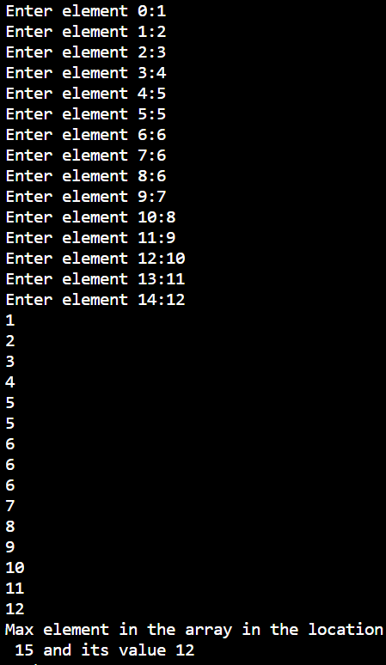

**Question No.9**

[PSEUDOCODE](https://www.google.com/search?rlz=1C1ONGR_enIN1012IN1012&q=what+is+pseudocode&spell=1&sa=X&ved=2ahUKEwi4_6eW2av5AhWf-DgGHQuOD04QBSgAegQIARAz)

/*

Home Assignment

/9/

You are given an array of 0s and 1s

in random order. Segregate 0s on left

side and 1s on right side of the array. Traverse array only once.

*/

#include<stdio.h>

void segregate0and1(int arr[], int size)

{

    int left = 0, right = size-1;

    while (left < right)

    {

        while (arr[left] == 0 && left < right)

            left++;

        while (arr[right] == 1 && left < right)

            right--;

        if (left < right)

        {

            arr[left] = 0;

            arr[right] = 1;

            left++;

            right--;

        }

    }

}

int main()

{

    int arr[] = {0, 1, 0, 1, 1, 1};

    int i, arr_size = sizeof(arr)/sizeof(arr[0]);

    segregate0and1(arr, arr_size);

    printf("Array after segregation ");

    for (i = 0; i < 6; i++)

        printf("%d ", arr[i]);

    getchar();

    return 0;

}

OUTPUT 9



**Question No.10**

[PSEUDOCODE](https://www.google.com/search?rlz=1C1ONGR_enIN1012IN1012&q=what+is+pseudocode&spell=1&sa=X&ved=2ahUKEwi4_6eW2av5AhWf-DgGHQuOD04QBSgAegQIARAz)

/*

Home Assignment

/10/

WAP to swap all the elements in the 1st column with all the corresponding elements in the last column, and 2nd column with the second last column and 3rd with 3rd last etc. of a 2-D dynamic array. Display the matrix.

*/

#define _CRT_SECURE_NO_WARNINGS

#include <stdio.h>

#include <stdlib.h>

void InpMat(int** mat, int rows, int cols)//

{

    printf("Please enter elements matrix:\n");

    for (int i = 0; i < rows; i++)

    {

        for (int j = 0; j < cols; j++)

            scanf("%i", &mat[i][j]);

    }

}

void OutMat(int** mat, int rows, int cols)//

{

    printf("Final Matrix is \n");

    for (int i = 0; i < rows; i++)

    {

        for (int j = 0; j < cols; j++)

            printf("%3d", mat[i][j]);

        printf("\n");

    }

}

void ChangeMat(int** mat, int rows, int cols)

{

    int l = 0;

    int r = cols-1;

    while (l < r)

    {

        for (int i = 0; i < rows; i++)

        {

            int temp = mat[i][l];

            mat[i][l] = mat[i][r];

            mat[i][r] = temp;

        }

        l++;

        r--;

    }

}

int main()

{

    int rows, cols;

    printf("Please enter rows and columns of matrix:\n");

    scanf("%i%i", &rows, &cols);

    int** mat = (int**)malloc(sizeof(int*) * (size_t)rows);

    for (int i = 0; i < rows; i++)

        mat[i] = (int*)malloc(sizeof(int) * (size_t)cols);

    InpMat(mat, rows, cols);

    ChangeMat(mat, rows, cols);

    OutMat(mat, rows, cols);

    free(mat);

    return 0;

}

OUTPUT 10

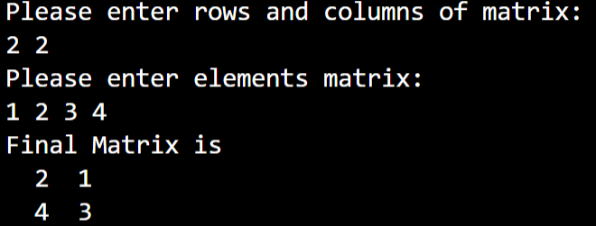

Question No.11 is repeated question of question no.3.

Thank You  
-Akash Jaiswal  
-CSE-12  
-21052935